WPL LAB 3
name: Abhinav Singh Bhagtana
section: A
roll no: 29
reg no: 230905225

Q1.Design the student bio-data form using button, label, textbox, radio button, table
and checkbox.
<!DOCTYPE html>
<html lang="en">
<head>
<meta charset="UTF-8">
<meta name="viewport" content="width=device-width, initial-scale=1.0">
<title>Premium Student Bio-Data</title>
<link href="https://cdn.jsdelivr.net/npm/bootstrap@5.3.0/dist/css/bootstrap.min.css" rel="stylesheet">
<link rel="stylesheet" href="https://cdnjs.cloudflare.com/ajax/libs/font-awesome/6.4.0/css/all.min.css">
<link href="https://fonts.googleapis.com/css2?family=Inter:wght@400;500;600;700&display=swap" rel="stylesheet">

<style>
body {
background: linear-gradient(135deg, #f5f7fa 0%, #c3cfe2 100%);
font-family: 'Inter', sans-serif;
min-height: 100vh;
padding: 40px 0;
}
.form-card {
background: #ffffff;
border: none;
border-radius: 15px;
box-shadow: 0 10px 30px rgba(0,0,0,0.1);
overflow: hidden;
}
.card-header-custom {
background: #4e73df;
background: linear-gradient(45deg, #4e73df, #224abe);
color: white;
padding: 25px;
text-align: center;
}
.section-title {
font-size: 0.9rem;
font-weight: 700;
text-transform: uppercase;
letter-spacing: 1px;
color: #4e73df;
border-bottom: 2px solid #eef2f7;
padding-bottom: 10px;
margin-bottom: 20px;
}
.form-label { font-weight: 500; color: #444; }
.input-group-text { background-color: #f8f9fc; color: #4e73df; }
.table thead { background-color: #f8f9fc; }
.btn-submit {
background: #4e73df;
border: none;
padding: 12px 30px;
font-weight: 600;
transition: all 0.3s;
}
.btn-submit:hover { background: #224abe; transform: translateY(-1px); }
</style>
</head>
<body>

<div class="container">
<div class="row justify-content-center">
<div class="col-lg-9">
<div class="card form-card">
<div class="card-header-custom">
<h3 class="mb-0">Student Bio-Data Portal</h3>
<p class="mb-0 opacity-75">Please fill in the information accurately</p>
</div>

<div class="card-body p-4 p-md-5">
<form>
<div class="section-title"><i class="fas fa-user me-2"></i> Personal Information</div>
<div class="row g-3 mb-4">
<div class="col-md-6">
<label class="form-label">Full Name</label>
<div class="input-group">
<span class="input-group-text"><i class="fas fa-user"></i></span>
<input type="text" class="form-control" placeholder="John Doe">
</div>
</div>
<div class="col-md-6">
<label class="form-label">Email ID</label>
<div class="input-group">
<span class="input-group-text"><i class="fas fa-envelope"></i></span>
<input type="email" class="form-control" placeholder="john@example.com">
</div>
</div>
<div class="col-md-6">
<label class="form-label">Gender</label>
<div class="pt-2">
<div class="form-check form-check-inline">
<input class="form-check-input" type="radio" name="g" id="m">
<label class="form-check-label" for="m">Male</label>
</div>
<div class="form-check form-check-inline">
<input class="form-check-input" type="radio" name="g" id="f">
<label class="form-check-label" for="f">Female</label>
</div>
</div>
</div>
<div class="col-md-6">
<label class="form-label">Interests</label>
<div class="pt-2">
<div class="form-check form-check-inline">
<input class="form-check-input" type="checkbox" id="c1">
<label class="form-check-label" for="c1">Tech</label>
</div>
<div class="form-check form-check-inline">
<input class="form-check-input" type="checkbox" id="c2">
<label class="form-check-label" for="c2">Art</label>
</div>
</div>
</div>
</div>

<div class="section-title"><i class="fas fa-graduation-cap me-2"></i> Academic Records</div>
<div class="table-responsive mb-4">
<table class="table table-hover border">
<thead>
<tr>
<th>Level</th>
<th>Institute / Board</th>
<th style="width: 120px;">Year</th>
<th style="width: 120px;">Score (%)</th>
</tr>
</thead>
<tbody>
<tr>
<td class="align-middle fw-medium">Secondary</td>
<td><input type="text" class="form-control form-control-sm"></td>
<td><input type="number" class="form-control form-control-sm"></td>
<td><input type="text" class="form-control form-control-sm"></td>
</tr>
<tr>
<td class="align-middle fw-medium">Higher Secondary</td>
<td><input type="text" class="form-control form-control-sm"></td>
<td><input type="number" class="form-control form-control-sm"></td>
<td><input type="text" class="form-control form-control-sm"></td>
</tr>
</tbody>
</table>
</div>

<div class="d-flex gap-3 justify-content-end mt-4">
<button type="reset" class="btn btn-light px-4 text-muted">Reset</button>
<button type="submit" class="btn btn-primary btn-submit">Submit Application</button>
</div>
</form>
</div>
</div>
</div>
</div>
</div>

</body>
</html>
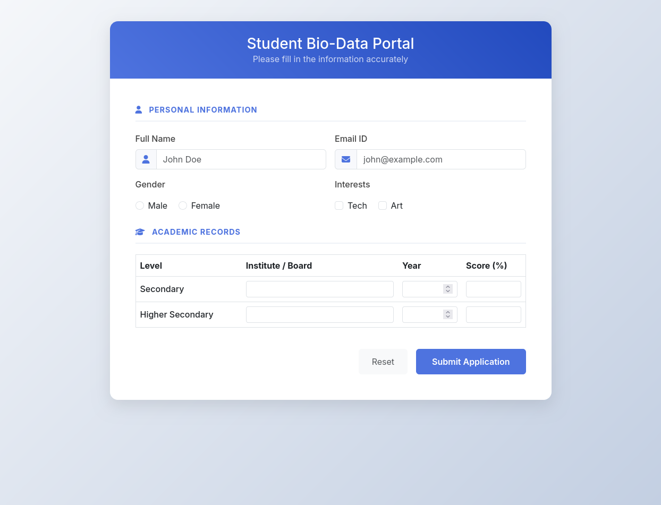
Q2.Design a web page which shows the database-oriented CRUD operation. Consider
Employee data.
<!DOCTYPE html>
<html lang="en">
<head>
<meta charset="UTF-8">
<meta name="viewport" content="width=device-width, initial-scale=1.0">
<title>Employee CRUD System</title>
<link href="https://cdn.jsdelivr.net/npm/bootstrap@5.3.0/dist/css/bootstrap.min.css" rel="stylesheet">
<link rel="stylesheet" href="https://cdnjs.cloudflare.com/ajax/libs/font-awesome/6.4.0/css/all.min.css">
<style>
body { background-color: #f4f7f6; font-family: 'Segoe UI', Tahoma, Geneva, Verdana, sans-serif; }
.main-card { border: none; border-radius: 12px; box-shadow: 0 5px 15px rgba(0,0,0,0.05); }
.table-container { background: white; border-radius: 12px; padding: 20px; box-shadow: 0 5px 15px rgba(0,0,0,0.05); }
.btn-action { padding: 5px 10px; font-size: 0.85rem; }
.status-badge { font-size: 0.75rem; padding: 5px 10px; border-radius: 20px; }
</style>
</head>
<body>

<nav class="navbar navbar-dark bg-dark mb-4">
<div class="container">
<span class="navbar-brand mb-0 h1"><i class="fas fa-users-cog me-2"></i> Employee Management System</span>
</div>
</nav>

<div class="container-fluid px-4">
<div class="row g-4">
<div class="col-lg-4">
<div class="card main-card">
<div class="card-header bg-white py-3">
<h5 class="mb-0 text-primary" id="formTitle">Add New Employee</h5>
</div>
<div class="card-body">
<form id="employeeForm">
<div class="mb-3">
<label class="form-label">Full Name</label>
<input type="text" id="fullName" class="form-control" placeholder="Enter name" required>
</div>
<div class="mb-3">
<label class="form-label">Designation</label>
<select id="designation" class="form-select" required>
<option value="" selected disabled>Select Role</option>
<option>Software Engineer</option>
<option>Project Manager</option>
<option>UI/UX Designer</option>
<option>HR Specialist</option>
</select>
</div>
<div class="mb-3">
<label class="form-label">Employee ID</label>
<input type="text" id="empId" class="form-control" placeholder="EMP-1001" required>
</div>
<div class="mb-3">
<label class="form-label">Department</label>
<div class="pt-1">
<div class="form-check form-check-inline">
<input class="form-check-input" type="radio" name="dept" id="it" value="IT" checked>
<label class="form-check-label" for="it">IT</label>
</div>
<div class="form-check form-check-inline">
<input class="form-check-input" type="radio" name="dept" id="sales" value="Sales">
<label class="form-check-label" for="sales">Sales</label>
</div>
</div>
</div>
<div class="mb-4">
<label class="form-label">Skills</label>
<div class="row g-2">
<div class="col-6"><input type="checkbox" class="form-check-input skill-check" value="Java"> Java</div>
<div class="col-6"><input type="checkbox" class="form-check-input skill-check" value="Python"> Python</div>
<div class="col-6"><input type="checkbox" class="form-check-input skill-check" value="SQL"> SQL</div>
<div class="col-6"><input type="checkbox" class="form-check-input skill-check" value="React"> React</div>
</div>
</div>
<div class="d-grid gap-2">
<button type="submit" class="btn btn-primary" id="saveBtn"><i class="fas fa-save me-2"></i> Save Employee</button>
<button type="reset" class="btn btn-outline-secondary" id="cancelBtn">Cancel</button>
</div>
</form>
</div>
</div>
</div>

<div class="col-lg-8">
<div class="table-container">
<div class="d-flex justify-content-between align-items-center mb-4">
<h5 class="mb-0">Employee Records</h5>
<div class="input-group w-50">
<span class="input-group-text bg-white border-end-0"><i class="fas fa-search text-muted"></i></span>
<input type="text" id="searchInput" class="form-control border-start-0" placeholder="Search employees...">
</div>
</div>

<div class="table-responsive">
<table class="table table-hover align-middle">
<thead class="table-light">
<tr>
<th>ID</th>
<th>Name</th>
<th>Designation</th>
<th>Dept</th>
<th class="text-center">Actions</th>
</tr>
</thead>
<tbody id="employeeTableBody">
</tbody>
</table>
</div>
</div>
</div>
</div>
</div>

<div class="modal fade" id="deleteModal" tabindex="-1">
<div class="modal-dialog modal-dialog-centered">
<div class="modal-content">
<div class="modal-body text-center py-4">
<i class="fas fa-exclamation-circle text-danger fa-3x mb-3"></i>
<h5>Are you sure?</h5>
<p class="text-muted">You won't be able to revert this employee record!</p>
<div class="d-flex justify-content-center gap-2 mt-4">
<button type="button" class="btn btn-light" data-bs-dismiss="modal">Cancel</button>
<button type="button" id="confirmDelete" class="btn btn-danger">Yes, Delete it!</button>
</div>
</div>
</div>
</div>
</div>

<script src="https://code.jquery.com/jquery-3.6.0.min.js"></script>
<script src="https://cdn.jsdelivr.net/npm/bootstrap@5.3.0/dist/js/bootstrap.bundle.min.js"></script>

<script>
$(document).ready(function() {
// Initial dummy data
let employees = [
{ id: 'EMP-101', name: 'Alice Johnson', role: 'Software Engineer', dept: 'IT', skills: ['Java', 'React'] },
{ id: 'EMP-102', name: 'Robert Smith', role: 'Project Manager', dept: 'Sales', skills: ['SQL'] }
];

let editMode = false;
let editId = null;
let idToDelete = null;

// 1. Function to display data
function renderTable(data = employees) {
const tbody = $('#employeeTableBody');
tbody.empty();

data.forEach(emp => {
const row = `
<tr data-id="${emp.id}">
<td class="fw-bold">${emp.id}</td>
<td>${emp.name}</td>
<td>${emp.role}</td>
<td><span class="badge bg-info-subtle text-info status-badge">${emp.dept}</span></td>
<td class="text-center">
<button class="btn btn-light btn-action text-primary me-1 edit-btn"><i class="fas fa-edit"></i></button>
<button class="btn btn-light btn-action text-danger delete-btn"><i class="fas fa-trash"></i></button>
</td>
</tr>`;
tbody.append(row);
});
}

// 2. Save / Update Employee
$('#employeeForm').on('submit', function(e) {
e.preventDefault();

const selectedSkills = [];
$('.skill-check:checked').each(function() {
selectedSkills.push($(this).val());
});

const empData = {
id: $('#empId').val(),
name: $('#fullName').val(),
role: $('#designation').val(),
dept: $('input[name="dept"]:checked').val(),
skills: selectedSkills
};

if (editMode) {
const index = employees.findIndex(e => e.id === editId);
employees[index] = empData;
editMode = false;
$('#formTitle').text('Add New Employee');
$('#empId').prop('readonly', false);
} else {
employees.push(empData);
}

this.reset();
renderTable();
});

// 3. Edit Record
$(document).on('click', '.edit-btn', function() {
const id = $(this).closest('tr').data('id');
const emp = employees.find(e => e.id === id);

if (emp) {
editMode = true;
editId = id;
$('#formTitle').text('Edit Employee: ' + id);
$('#empId').val(emp.id).prop('readonly', true);
$('#fullName').val(emp.name);
$('#designation').val(emp.role);
$(`input[name="dept"][value="${emp.dept}"]`).prop('checked', true);

$('.skill-check').prop('checked', false);
emp.skills.forEach(skill => {
$(`.skill-check[value="${skill}"]`).prop('checked', true);
});
}
});

// 4. Delete Record
$(document).on('click', '.delete-btn', function() {
idToDelete = $(this).closest('tr').data('id');
$('#deleteModal').modal('show');
});

$('#confirmDelete').on('click', function() {
employees = employees.filter(e => e.id !== idToDelete);
renderTable();
$('#deleteModal').modal('hide');
});

// 5. Search Record
$('#searchInput').on('keyup', function() {
const value = $(this).val().toLowerCase();
const filtered = employees.filter(emp =>
emp.name.toLowerCase().includes(value) || emp.id.toLowerCase().includes(value)
);
renderTable(filtered);
});

// 6. Reset Form
$('#cancelBtn').on('click', function() {
editMode = false;
$('#formTitle').text('Add New Employee');
$('#empId').prop('readonly', false);
});

// Load table on start
renderTable();
});
</script>

</body>
</html>
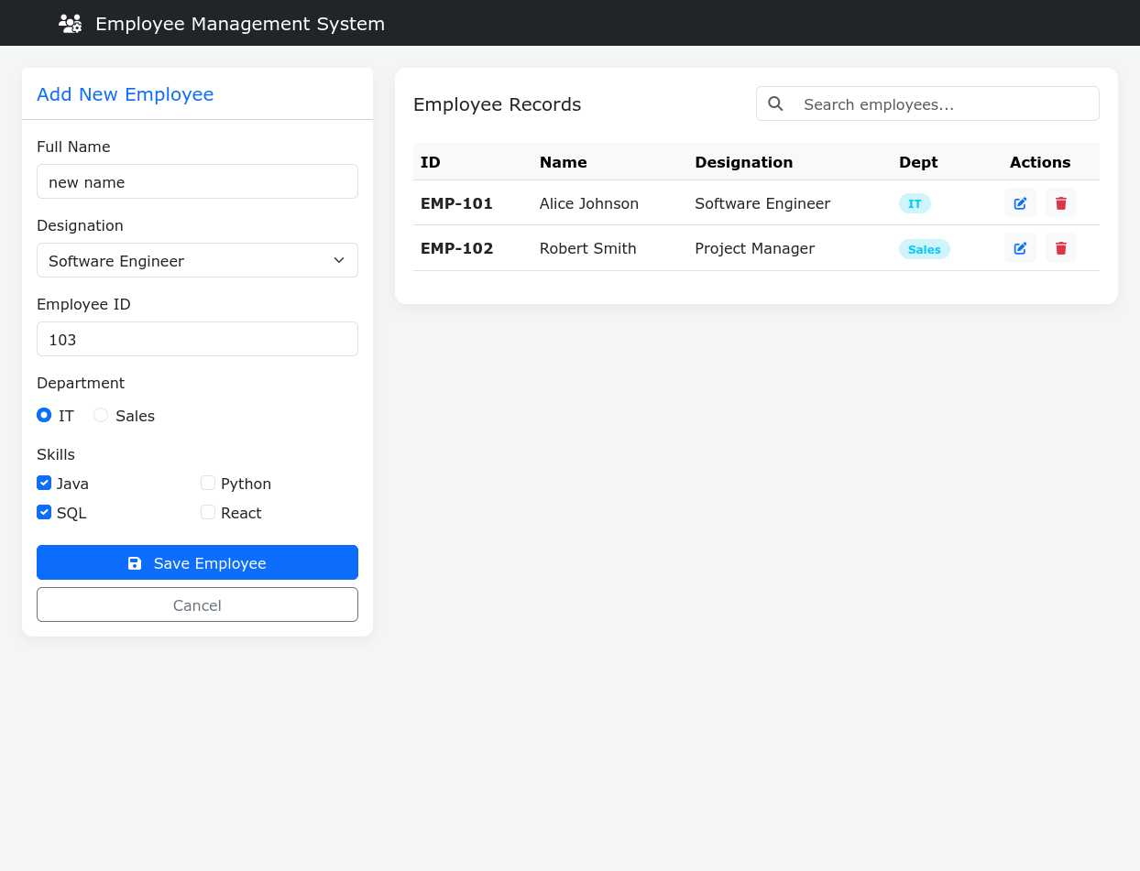

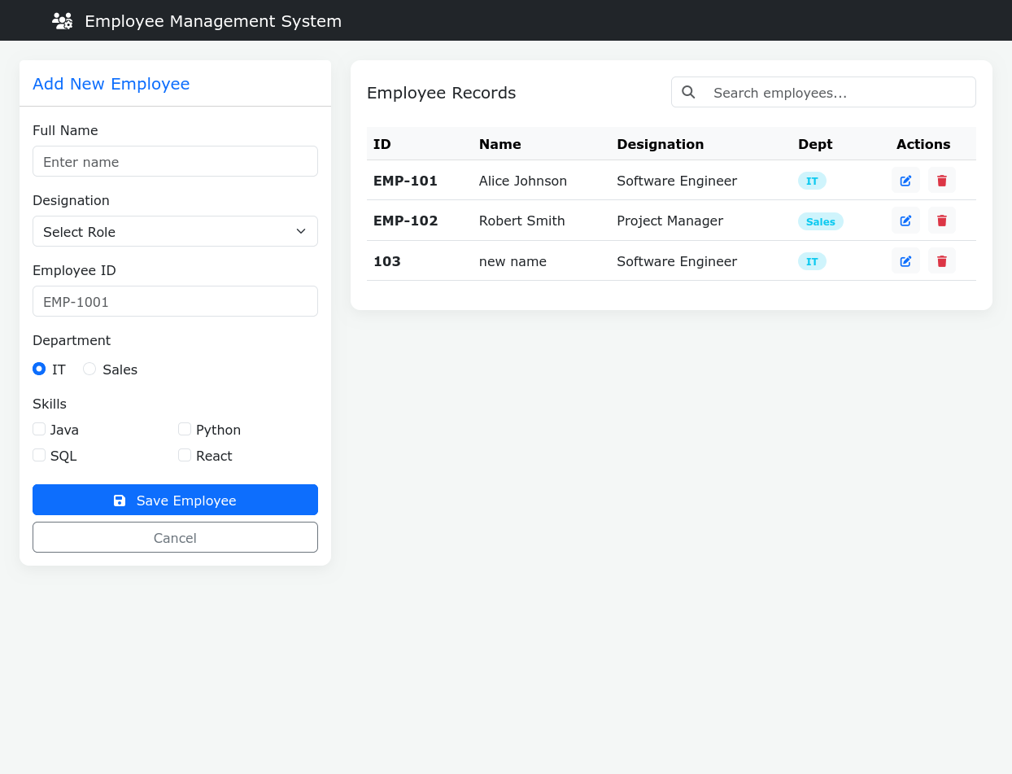
Q3.Create a web page using bootstrap as mentioned. Divide the page into 2 parts top
and bottom, then divide the bottom into 3 parts and design each top and bottom part using
different input groups, input, badges, buttons and button groups. Make the design more
attractive.
<!DOCTYPE html>
<html lang="en">
<head>
<meta charset="UTF-8">
<meta name="viewport" content="width=device-width, initial-scale=1.0">
<title>Interactive Dashboard</title>
<link href="https://cdn.jsdelivr.net/npm/bootstrap@5.3.0/dist/css/bootstrap.min.css" rel="stylesheet">
<style>
body { background-color: #f8f9fa; }
.top-section {
background: linear-gradient(135deg, #667eea 0%, #764ba2 100%);
color: white;
padding: 60px 0;
border-bottom: 5px solid #dee2e6;
}
.bottom-section { padding: 40px 0; }
.custom-card {
background: white;
border-radius: 15px;
padding: 25px;
box-shadow: 0 4px 15px rgba(0,0,0,0.1);
height: 100%;
transition: transform 0.3s;
}
.custom-card:hover { transform: translateY(-5px); }
</style>
</head>
<body>

<section class="top-section">
<div class="container">
<div class="row align-items-center">
<div class="col-md-8 offset-md-2 text-center">
<h1 class="display-4 fw-bold mb-3">Welcome Back <span class="badge bg-warning text-dark fs-6 align-middle">PRO</span></h1>
<p class="lead mb-4">Manage your projects and connect with your team instantly.</p>

<div class="input-group input-group-lg mb-3 shadow">
<span class="input-group-text bg-white border-0" id="search-addon">
<i class="bi bi-search">🔍</i>
</span>
<input type="text" class="form-control border-0" placeholder="Search resources, docs, or files..." aria-describedby="search-addon">
<button class="btn btn-dark px-4" type="button">Search</button>
</div>
</div>
</div>
</div>
</section>

<section class="bottom-section">
<div class="container">
<div class="row g-4">

<div class="col-md-4">
<div class="custom-card">
<h4 class="mb-3">Notifications <span class="badge rounded-pill bg-danger">3 New</span></h4>
<div class="mb-4">
<label class="form-label text-muted small fw-bold">QUICK BROADCAST</label>
<div class="input-group">
<input type="text" class="form-control" placeholder="Type a message...">
<button class="btn btn-outline-primary" type="button">Send</button>
</div>
</div>
<ul class="list-group list-group-flush">
<li class="list-group-item d-flex justify-content-between align-items-center bg-transparent">
Server Update
<span class="badge bg-success">Completed</span>
</li>
<li class="list-group-item d-flex justify-content-between align-items-center bg-transparent">
Client Meeting
<span class="badge bg-info">14:00 PM</span>
</li>
</ul>
</div>
</div>

<div class="col-md-4">
<div class="custom-card text-center">
<h4 class="mb-3">System Controls</h4>
<p class="text-muted">Adjust your environment settings.</p>

<div class="btn-group w-100 mb-4 shadow-sm" role="group" aria-label="Basic example">
<button type="button" class="btn btn-outline-secondary">Dev</button>
<button type="button" class="btn btn-outline-secondary active">Staging</button>
<button type="button" class="btn btn-outline-secondary">Prod</button>
</div>

<div class="d-grid gap-2">
<button class="btn btn-primary btn-lg" type="button">Deploy Changes</button>
<button class="btn btn-link text-decoration-none" type="button">View Logs</button>
</div>
</div>
</div>

<div class="col-md-4">
<div class="custom-card">
<h4 class="mb-3">Account Settings</h4>
<div class="mb-3">
<label for="username" class="form-label">Username</label>
<div class="input-group">
<span class="input-group-text">@</span>
<input type="text" class="form-control" id="username" placeholder="alex_design">
</div>
</div>
<div class="mb-4">
<label for="email" class="form-label">Support Email</label>
<input type="email" class="form-control" id="email" value="alex@example.com" readonly>
</div>
<div class="d-flex justify-content-between align-items-center">
<div class="btn-group btn-group-sm">
<button class="btn btn-secondary">Edit</button>
<button class="btn btn-outline-danger">Logout</button>
</div>
<span class="text-muted small">ID: 4402</span>
</div>
</div>
</div>

</div>
</div>
</section>

<script src="https://cdn.jsdelivr.net/npm/bootstrap@5.3.0/dist/js/bootstrap.bundle.min.js"></script>
</body>
</html>
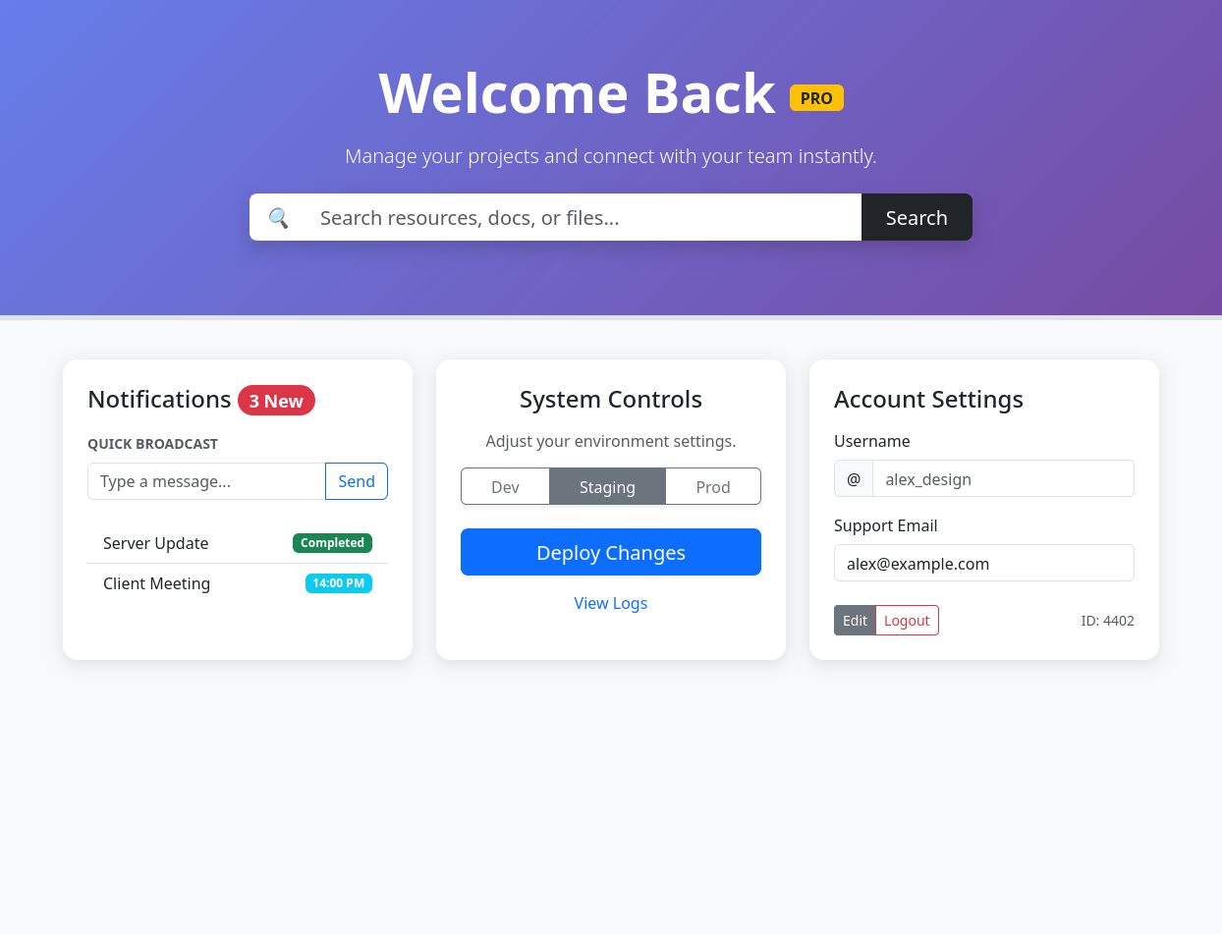
Q4.Design your class timetable using bootstrap table and carousel.
<!DOCTYPE html>
<html lang="en">
<head>
<meta charset="UTF-8">
<meta name="viewport" content="width=device-width, initial-scale=1.0">
<title>Weekly Academic Schedule</title>
<link href="https://cdn.jsdelivr.net/npm/bootstrap@5.3.0/dist/css/bootstrap.min.css" rel="stylesheet">
<style>
body { background-color: #f4f7f6; font-family: 'Segoe UI', Tahoma, Geneva, Verdana, sans-serif; }
.timetable-container { margin-top: 50px; margin-bottom: 50px; }
.carousel-item { padding: 20px; min-height: 400px; }
.table { background: white; border-radius: 12px; overflow: hidden; box-shadow: 0 10px 30px rgba(0,0,0,0.05); }
.table thead { background-color: #4a69bd; color: white; }
.day-header { font-size: 2.5rem; font-weight: 700; color: #1e3799; margin-bottom: 10px; }
.lab-session { border-left: 5px solid #f8c291; background-color: #fffaf5; }
.lecture-session { border-left: 5px solid #4a69bd; }
.control-btn { background-color: #1e3799; width: 45px; height: 45px; border-radius: 50%; top: 55%; transform: translateY(-50%); }
.lunch-break { background-color: #f1f2f6; color: #7f8c8d; font-style: italic; letter-spacing: 2px; }
</style>
</head>
<body>

<div class="container timetable-container">
<div class="row mb-4">
<div class="col-12 text-center">
<h1 class="day-header">Weekly Schedule</h1>
<span class="badge rounded-pill bg-dark">Spring Semester 2026</span>
</div>
</div>

<div id="timetableCarousel" class="carousel slide" data-bs-ride="false">
<div class="carousel-inner">

<div class="carousel-item active">
<h3 class="text-center mb-4 text-primary fw-bold">Monday</h3>
<table class="table table-hover align-middle text-center">
<thead>
<tr>
<th>Time</th>
<th>Subject</th>
<th>Location</th>
<th>Type</th>
</tr>
</thead>
<tbody>
<tr class="lecture-session">
<td>08:00 - 09:00</td>
<td class="fw-bold">PE-1</td>
<td>Room 212</td>
<td><span class="badge bg-primary">Lecture</span></td>
</tr>
<tr class="lecture-session">
<td>09:00 - 10:00</td>
<td class="fw-bold">Parallel Computer Architecture & Programming</td>
<td>Room 209</td>
<td><span class="badge bg-primary">Lecture</span></td>
</tr>
<tr class="lunch-break">
<td>10:00 - 10:30</td>
<td colspan="3">BREAK</td>
</tr>
<tr class="lecture-session">
<td>10:30 - 11:30</td>
<td class="fw-bold">Compiler Design</td>
<td>Room 209</td>
<td><span class="badge bg-primary">Lecture</span></td>
</tr>
<tr class="lecture-session">
<td>11:30 - 12:30</td>
<td class="fw-bold">Open Elective</td>
<td>Room 410</td>
<td><span class="badge bg-primary">Lecture</span></td>
</tr>
</tbody>
</table>
</div>

<div class="carousel-item">
<h3 class="text-center mb-4 text-primary fw-bold">Tuesday</h3>
<table class="table table-hover align-middle text-center">
<thead>
<tr>
<th>Time</th>
<th>Subject</th>
<th>Location</th>
<th>Type</th>
</tr>
</thead>
<tbody>
<tr class="lecture-session">
<td>09:00 - 10:30</td>
<td class="fw-bold">C Systems Programming</td>
<td>Seminar Room</td>
<td><span class="badge bg-primary">Lecture</span></td>
</tr>
<tr class="lecture-session">
<td>11:00 - 12:30</td>
<td class="fw-bold">Cryptography & Security</td>
<td>Hall B-201</td>
<td><span class="badge bg-info text-dark">Seminar</span></td>
</tr>
<tr class="lab-session">
<td>02:00 - 04:00</td>
<td class="fw-bold">Project Work: Python/FastAPI</td>
<td>Innovation Center</td>
<td><span class="badge bg-success">Development</span></td>
</tr>
</tbody>
</table>
</div>

<div class="carousel-item">
<h3 class="text-center mb-4 text-primary fw-bold">Wednesday</h3>
<table class="table table-hover align-middle text-center">
<thead>
<tr>
<th>Time</th>
<th>Subject</th>
<th>Location</th>
<th>Type</th>
</tr>
</thead>
<tbody>
<tr class="lecture-session">
<td>10:00 - 11:30</td>
<td class="fw-bold">Competitive Programming</td>
<td>Hall A-102</td>
<td><span class="badge bg-danger">Workshop</span></td>
</tr>
<tr class="lecture-session">
<td>12:00 - 01:00</td>
<td class="fw-bold">Web Development (jQuery)</td>
<td>Room 405</td>
<td><span class="badge bg-secondary">Hybrid</span></td>
</tr>
</tbody>
</table>
</div>

</div>

<button class="carousel-control-prev control-btn" type="button" data-bs-target="#timetableCarousel" data-bs-slide="prev">
<span class="carousel-control-prev-icon" aria-hidden="true"></span>
<span class="visually-hidden">Previous</span>
</button>
<button class="carousel-control-next control-btn" type="button" data-bs-target="#timetableCarousel" data-bs-slide="next">
<span class="carousel-control-next-icon" aria-hidden="true"></span>
<span class="visually-hidden">Next</span>
</button>
</div>
</div>

<script src="https://cdn.jsdelivr.net/npm/bootstrap@5.3.0/dist/js/bootstrap.bundle.min.js"></script>
</body>
</html>
Monday:
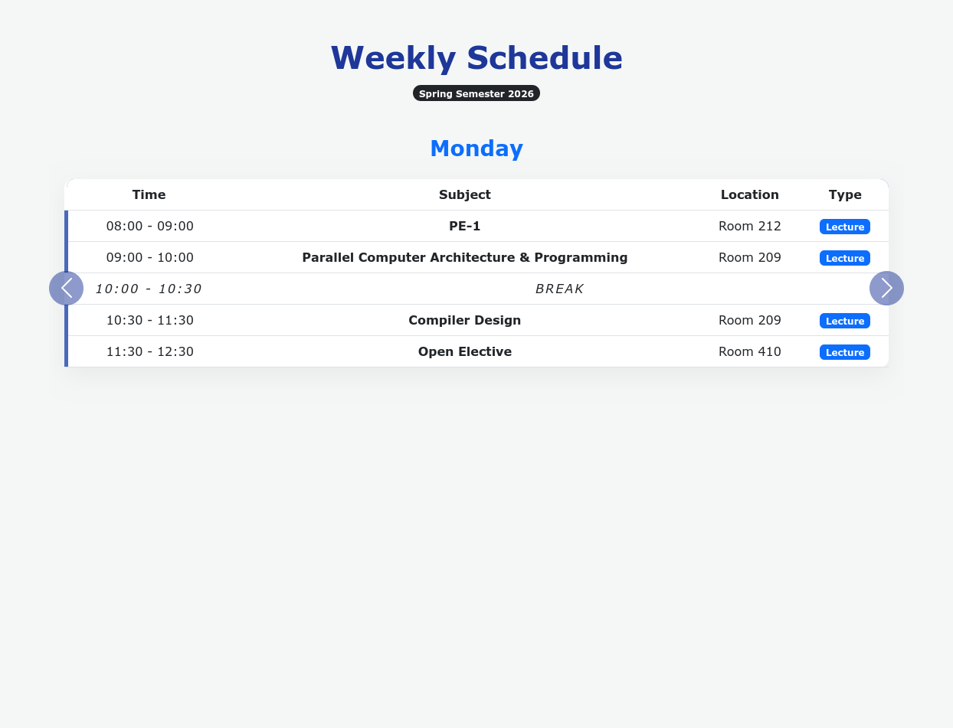
Wednesday:
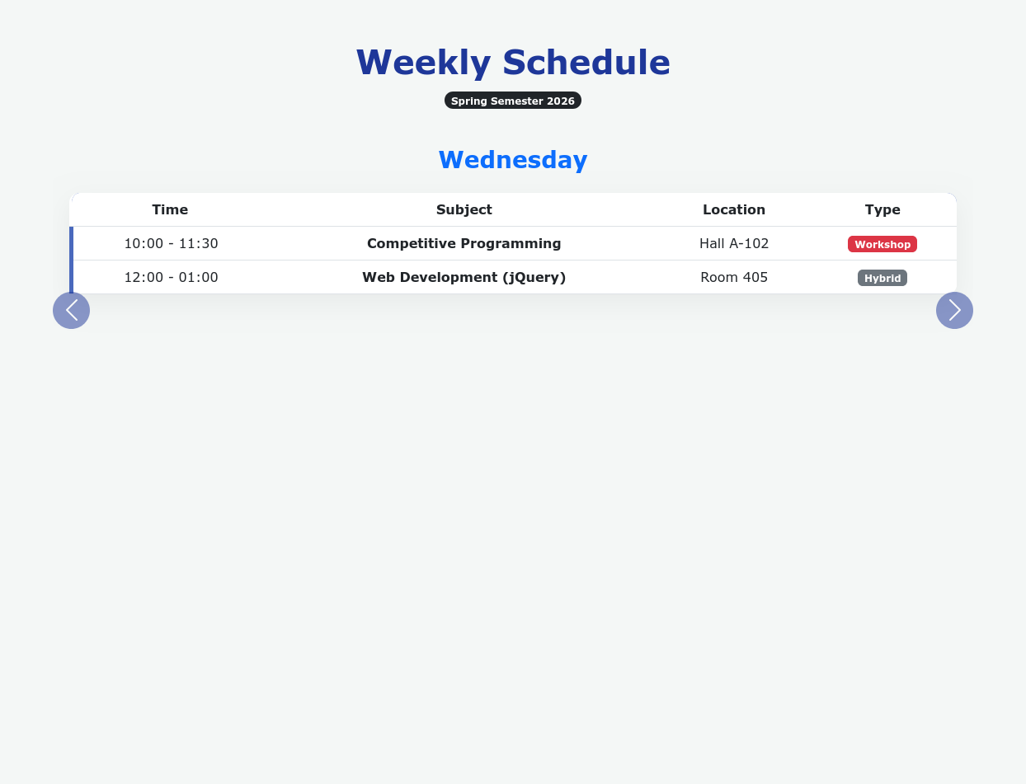
Tuesday:
